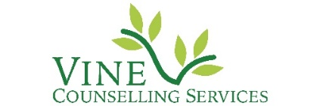
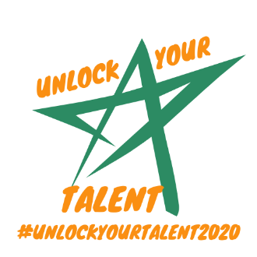
What’s it all about??

Unlock Your Talent is an online talent festival created by Multi award winning musician, songwriter and Sky Television music judge, Rachel Mason, in collaboration with and to raise funds for a counselling charity close to her heart - Vine Counselling Services, based in North Somerset (charity number ).

Vine Counselling Services offer donation based professional counselling to people in the community who are struggling due to bereavement, stress, anxiety, abuse, isolation, loneliness, family problems and other issues. During the Coronavirus lockdown imposed by the Government, Vine has set up a video/telephone service to enable them to continue to offer counselling at a time which is so difficult for many, until the charity can resume face to face counselling.

Rachel learned that the charity’s finances had been seriously affected by the current Covid 19 situation and wanted to help.

Rachel says….
“During lockdown I’ve been thinking a lot about how I can help support people. There are a handful of things that light a fire in me to create something new; supporting young people, being self-employed, raising money for charity, encouraging good mental health and bringing joy to people through the arts. It suddenly occurred to me that I could create one big event that ticked every single box, and so last week while I was awake at 3am with my 18-month-old the idea for the “Unlock Your Talent” Festival came to me!”
“The counsellors at Vine saved my life 13 years ago when I went through a mental health crisis during my divorce and almost died.”
Rachel has created the “Unlock Your Talent” online festival with a variety of different creative categories people across the UK can enter for a small fee which goes directly to Vine Counselling Services via a Just Giving page. The festival will include categories for all ages so that everyone can take part.
In addition to the amazing celebrity judges Rachel has personally sourced she has also selected a number of self-employed creatives from across the UK as judges. Rachel is the current Freelancer Of the Year and wants to support freelancers as much as possible especially now while they’re not able to work as much.

Rachel says ….
“Times are tough for many people right now but especially those who are self-employed. I really want to support as many of them as possible but as I’m not really making any money at the moment due to work has been cancelled, I can’t help them financially. However, through this festival I can give them as much free publicity as possible so many people hear about their business and may book them after lockdown.”
As a vocal teacher and mentor to young musicians Rachel is also aware of how many young people are feeling bereft having worked so hard on their art, music, media and dance GCSE, A Level and Degree coursework only to be told that it will not be seen by any teachers or examiners and will not be marked. They feel so sad that their hard work was all in vain so by holding this festival Rachel is aiming to raise the spirits of these creative young people by inviting them to enter the festival and have their work reviewed by industry professionals. Many parents of teenagers have been in touch with her over the last couple of months to ask if she can offer some support to their children. Rachel mentors young creatives so knows how hard they’re finding life at the moment. School ending so abruptly has affected their mental health and many of them are heartbroken that the coursework they worked so hard on will not be marked. Through this festival she is hoping to raise their spirits and give them the opportunity to show their work to industry professionals from all over the world.
Over the last 10 years Rachel has raised £50,000 for charities including Vine Counselling Services, The Diana Trust, WellChild and Barnardos. Through the “Unlock Your Talent” festival Rachel hopes to raise as much money as possible for Vine Counselling Services so the greatest number of people can receive support for their mental health through the Covid 19 pandemic and beyond.

Go to www.vinecounselling.org to donate or to find all the relevant information and how to enter “Unlock Your Talent”.

